Visiting the
Grand Rapids Public Museum
A Social Story

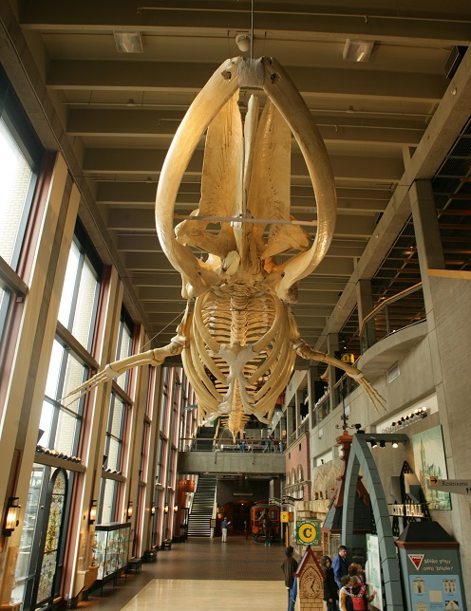

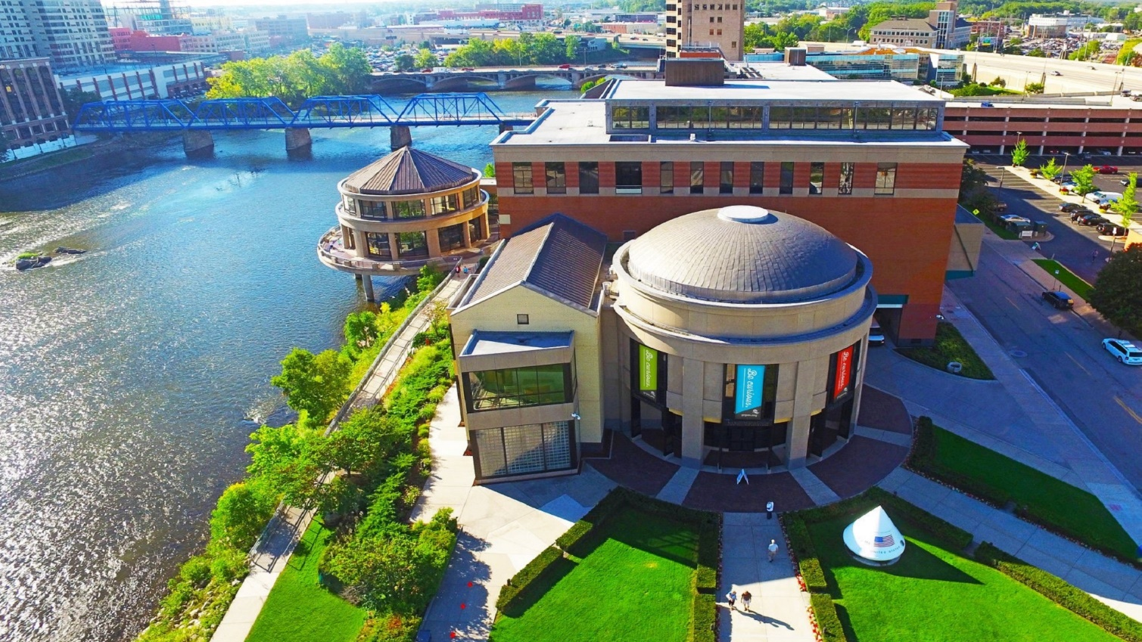
I am going to the Grand Rapids Public Museum. It is a fun place to learn about history, science, and culture. There are many things I can see and do.

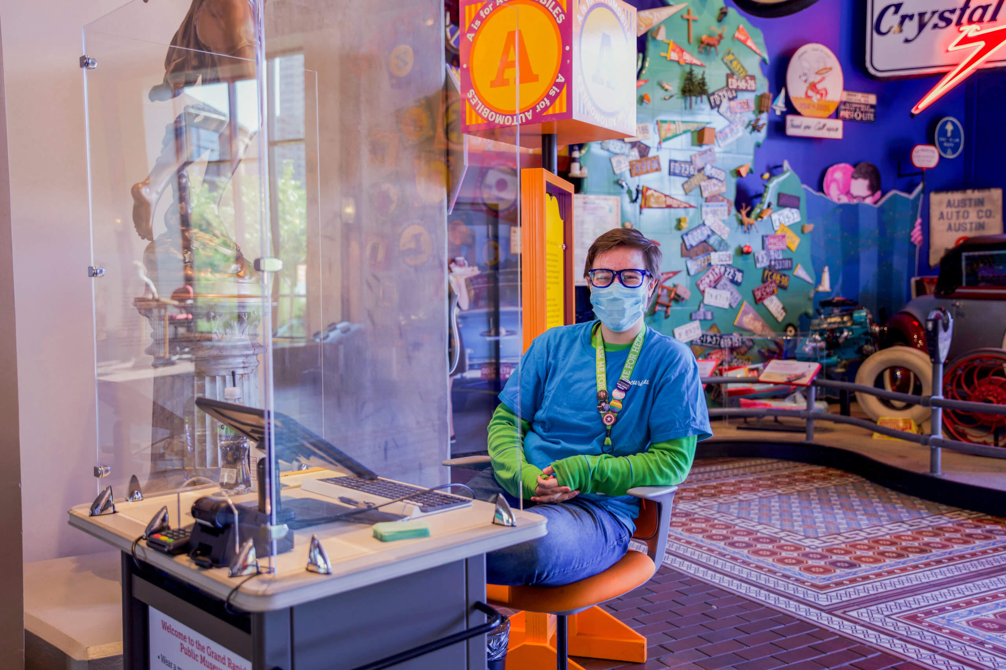
A friendly staff member sitting near the main entrance.
At the museum, I may need to wait in line. During my visit, I will stay with my grown-up and use my walking feet. If I have a question, a staff member will help me.

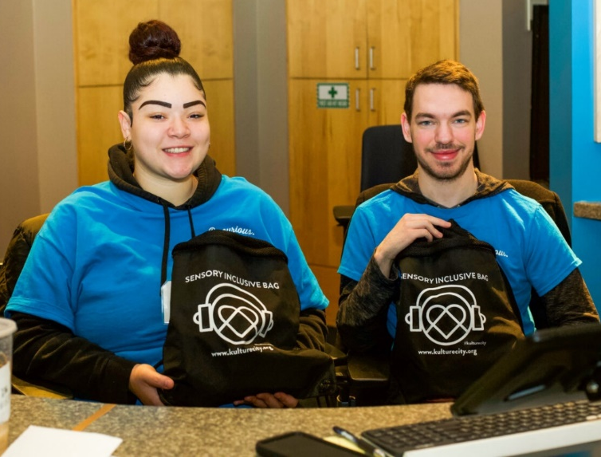
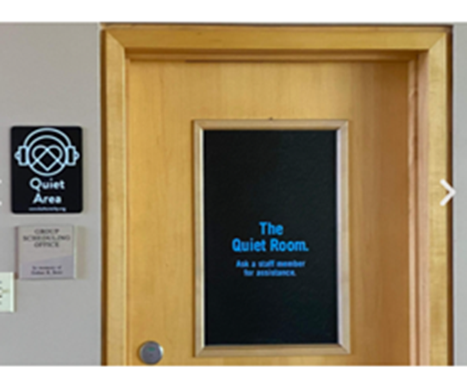
See the front desk to access the quiet room and headphones.
Sometimes the museum gets noisy. Other people are excited to be here too! If the noise gets too loud, I can take a break in the quiet room, or ask a staff member for headphones.

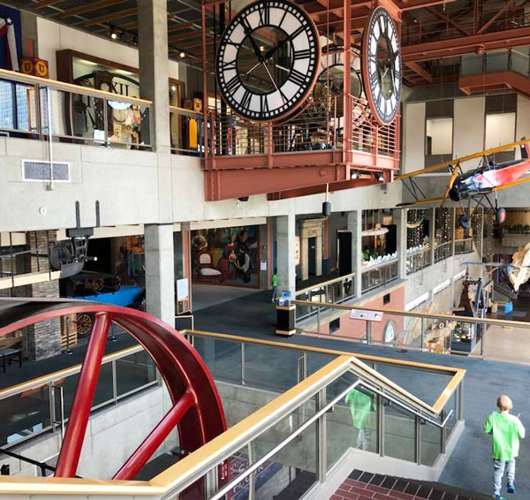
A view from the second floor at the Grand Rapids Public Museum.
The museum has three floors I can explore. When I am ready to go upstairs, I can use the elevator, or take the stairs.

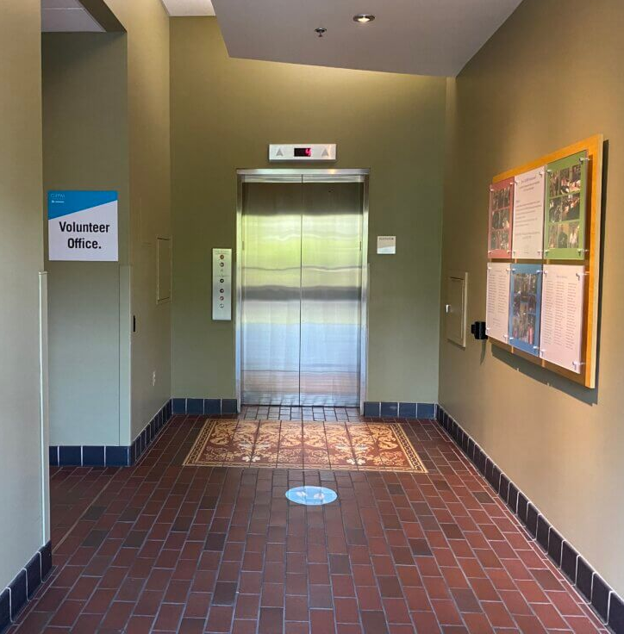
The museum has one elevator. I may have to wait in line to use the elevator. That is OK! It is good to wait so everyone can have a turn.
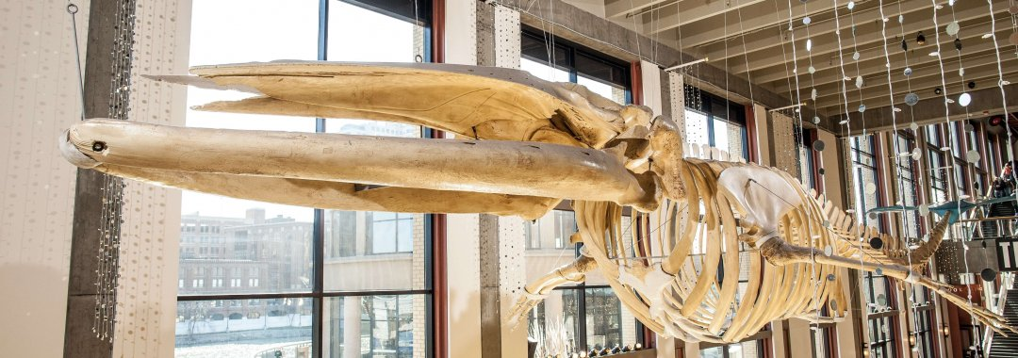
Finback whales can grow 75 feet long and weigh 80-90 tons.
On the first floor, I will meet “Finny” the finback whale. His skeleton hangs from the ceiling in the Galleria. I can explore virtual activities to learn about where fin whales live, and what they like to eat.

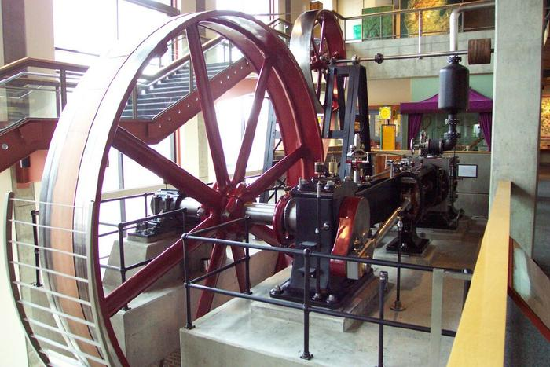
This Corliss valve steam engine was built in Ohio in 1905.

On the second floor, I will see a Corliss valve steam engine. The wheel measures 35 feet wide and weighs over 12 tons! In the early 1900’s, this steam engine generated power at the St. John’s Table Company in Cadillac, Michigan.
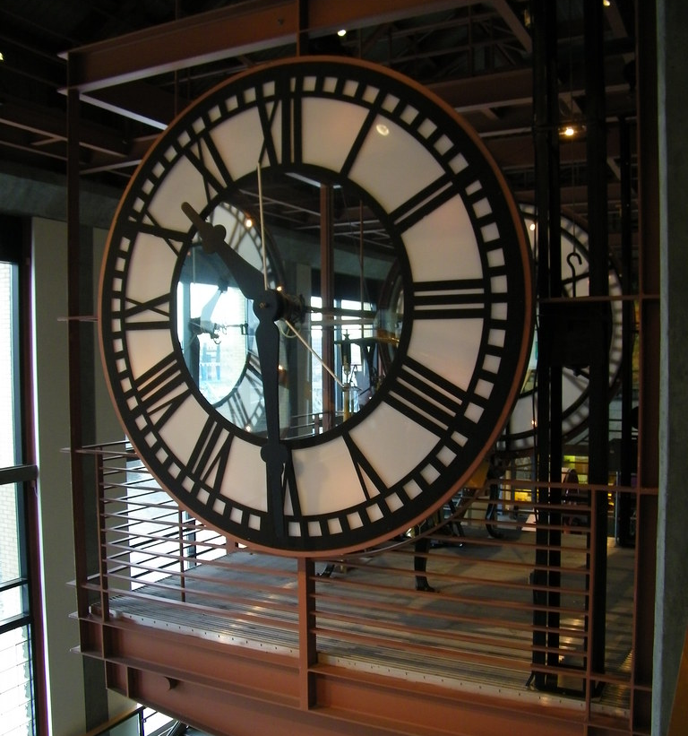
The Grand Rapids City Hall Tower Clock was built in Boston in 1880.
On the third floor, I will see the Grand Rapids City Hall tower clock. This clock has moving gears and a pendulum. Every hour, the clock has a loud chime. If the clock is too loud, I can wear my headphones or move away at any time.
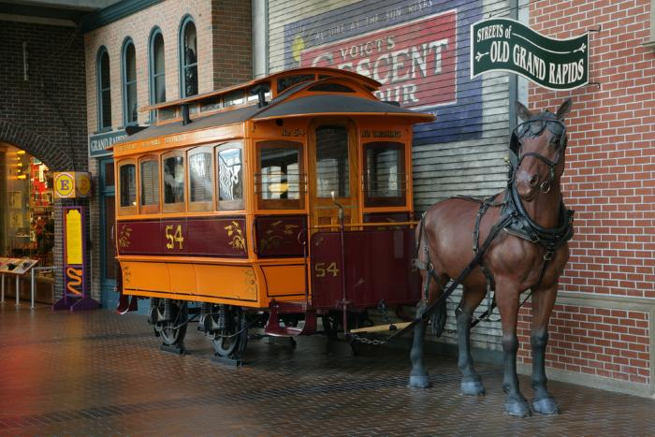
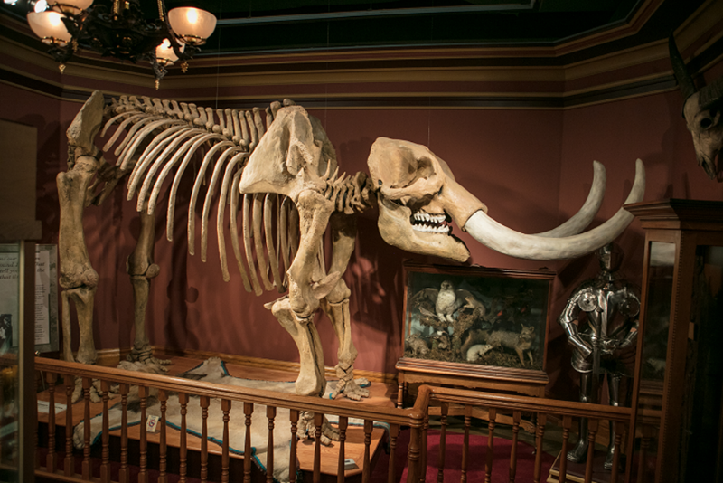
A horse drawn streetcar is a manmade artifact.
A mastodon skeleton is a scientific specimen.
When I visit the museum, I will see many manmade artifacts and scientific specimens on display. Artifacts are objects made by humans. Specimens are objects made by nature. Artifacts and specimens are important because they teach us how the world has changed over time.
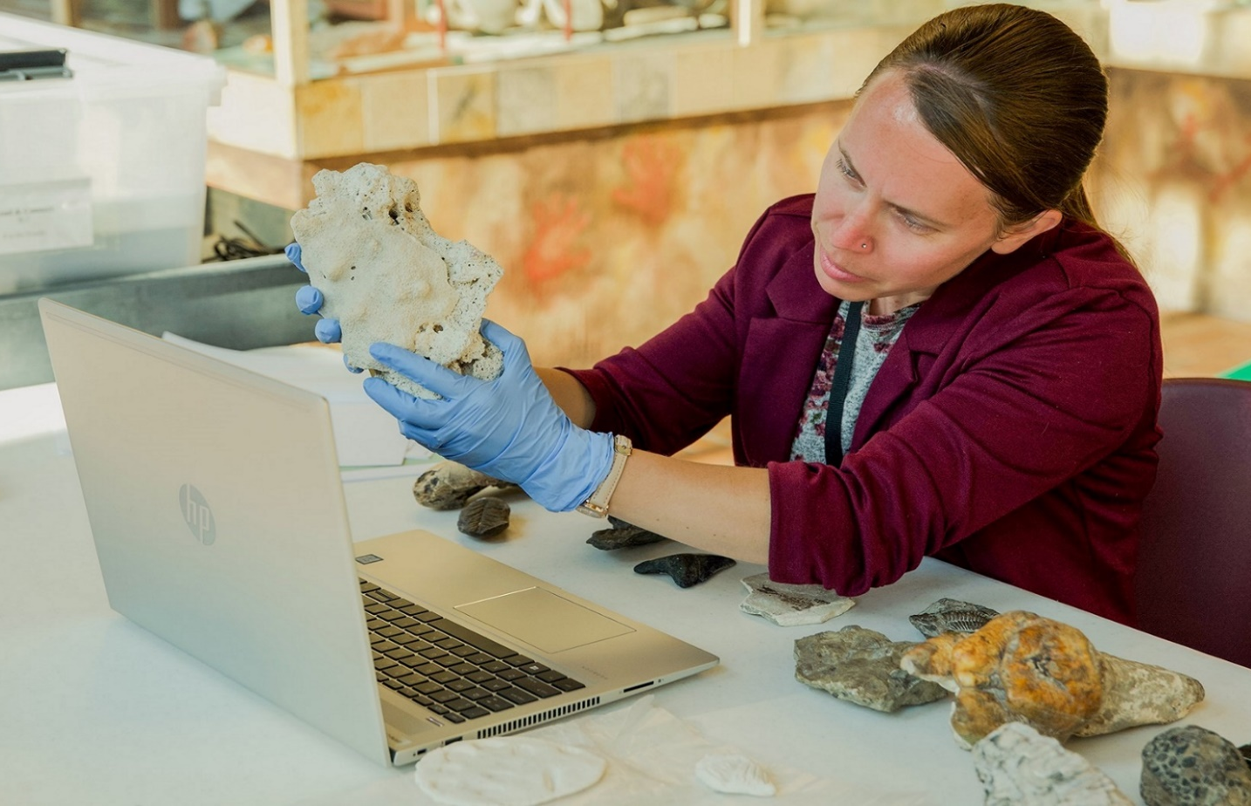
People with special training take care of the artifacts and specimens. This is an important job at the museum. When I visit the museum, I can look at the artifacts and specimens, but I should not touch them.

A collection of artifacts or specimen is called an exhibit. The museum has many exciting exhibits I can explore.
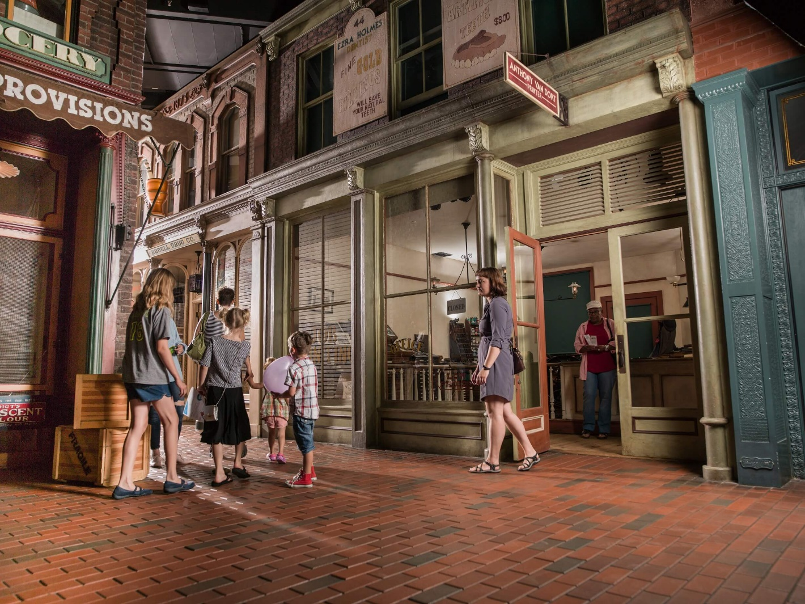

In the Streets of Old Grand Rapids exhibit, I can explore historic artifacts and storefronts. I can walk on brick streets and peddle a high wheeler bicycle. I can learn what life was like in West Michigan in the 1890’s.
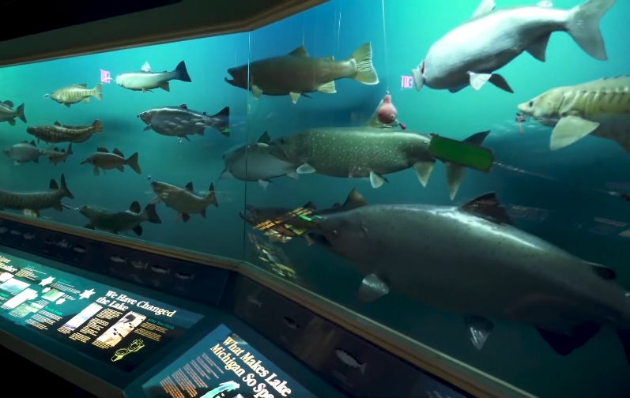
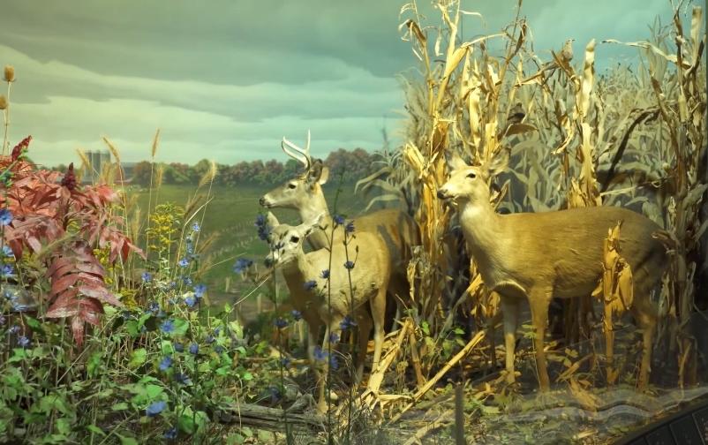
Dioramas of natural environments found in West Michigan.
In the West Michigan Habitats exhibit, I can learn about the plants, animals, and fish that live in our local lakes and forests. I can see dioramas of natural environments with interesting lights, sounds, and activities.

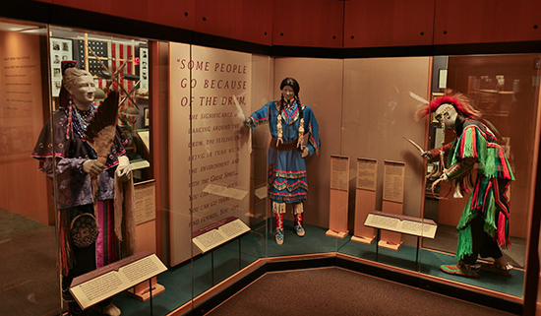
Artifacts representing the history and culture of the Anishinabek people.

In the Anishinabek: The People of this Place exhibit, I can learn about the first Native American people to settle in West Michigan. I can see many rare artifacts including decorative arts, clothing, weapons, and tools. This exhibit has a quiet area where I can get away from noise and crowds.
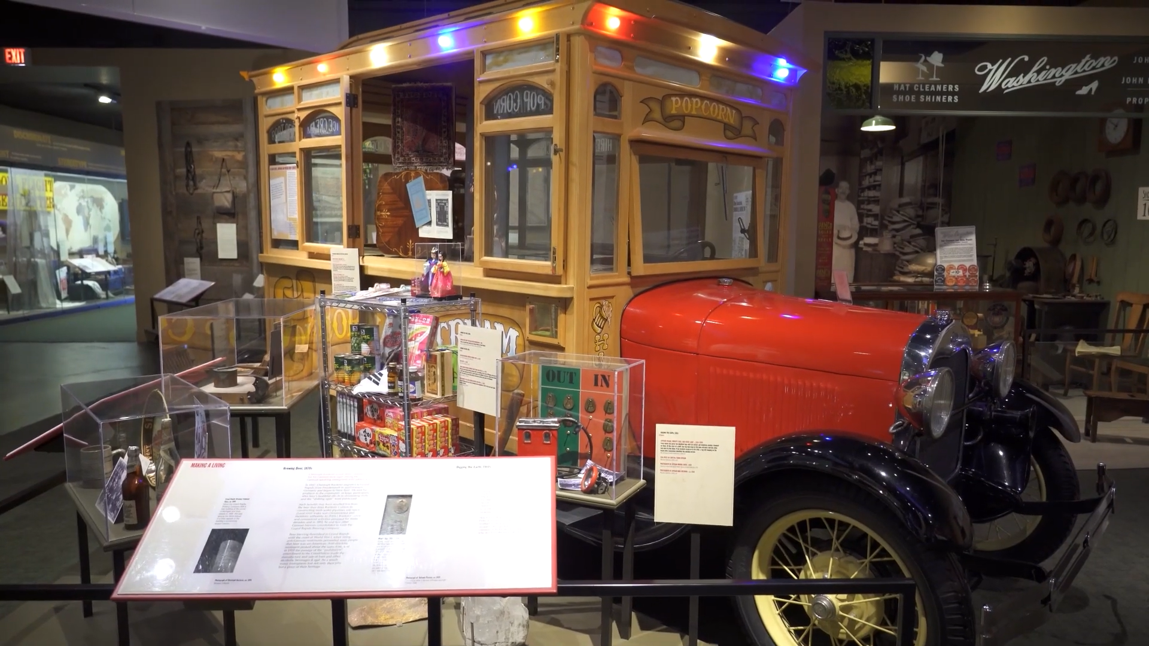
In the early 1900’s, popcorn trucks were a familiar sight in Grand Rapids.

The Newcomers: People of this Place exhibit tells stories of the people who came to West Michigan after the Anishinabek. This exhibit has over 600 artifacts, interactive maps, and photographs. Each object tells an interesting story about the history and culture of West Michigan.
Two baby lake sturgeon live at the Grand Rapids Public Museum.
In the Grand Fish, Grand River exhibit, I can learn about Lake Sturgeon, the largest and oldest fish in the Great Lakes. Sturgeon can grow up to 7 feet long and live for 150 years! I can learn about the history of fishing in West Michigan. I can meet two baby Lake Sturgeon who live at the museum.
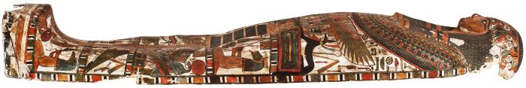
Inner coffin from Nakhte-Bastet-Iru’s sarcophagus dated 946 B.C.-712 B.C.

In the Egypt: Be Curious exhibit, I can see many ancient Egyptian artifacts and learn about customs. I can meet a real mummy that is over 3,000 years old! Her name is Nakhte-Bastet-Iru.

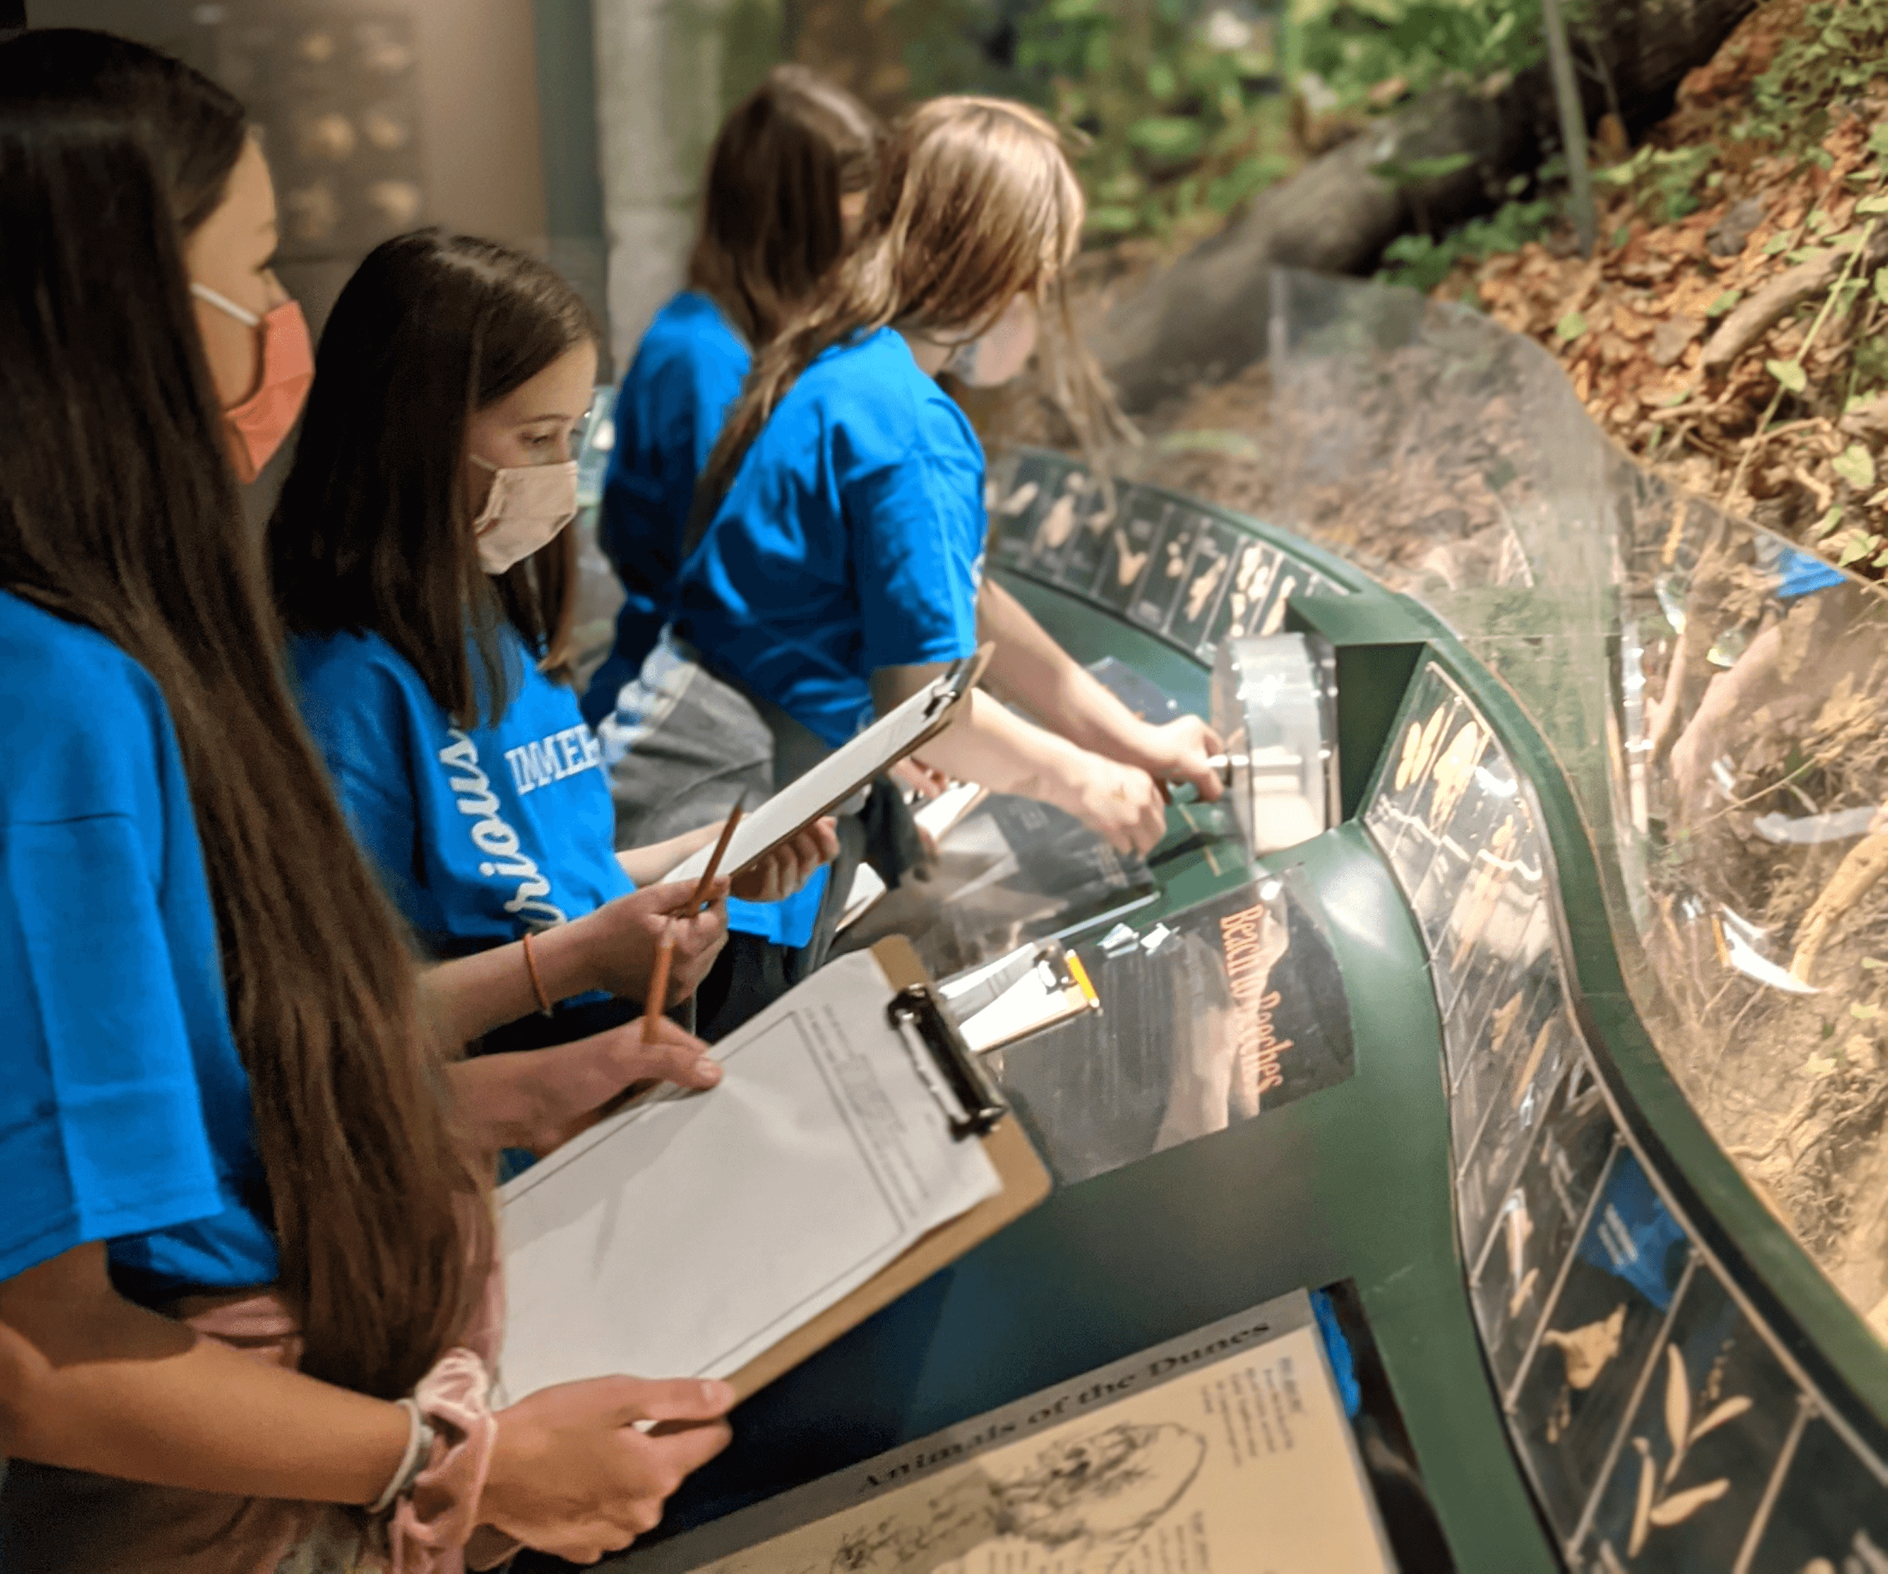
Children exploring the West Michigan Habitats exhibit.
Sometimes the museum is busy, and I may have to wait in line. That is OK! It is good to wait my turn so everyone can enjoy the artifacts and exhibits.

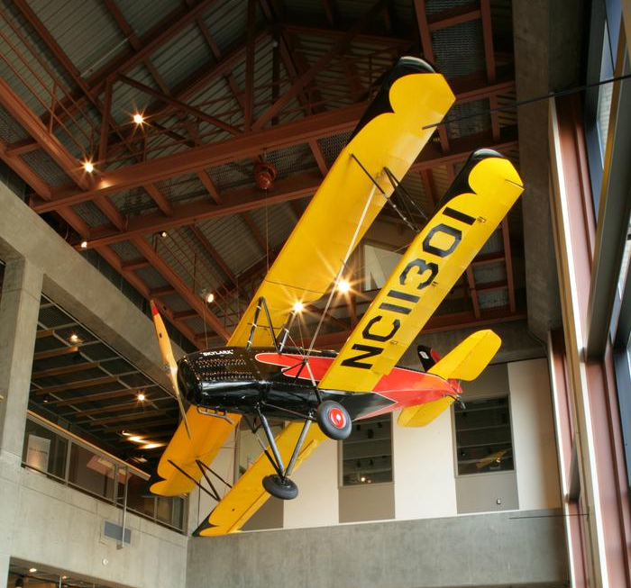
A Driggs Skylark Biplane hangs above the Galleria.
Sometimes the exhibits change. If an exhibit is closed when I visit the museum, that is OK! There are many other exciting things I can see and do.
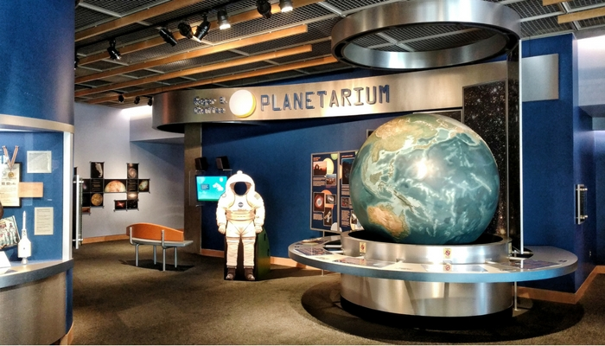
Roger B. Chaffee was an astronaut born in Grand Rapids.
I can visit the Roger B. Chaffee Planetarium to learn about outer space. Watching a show in the planetarium is like going to the movies, except the movie screen is on the ceiling!
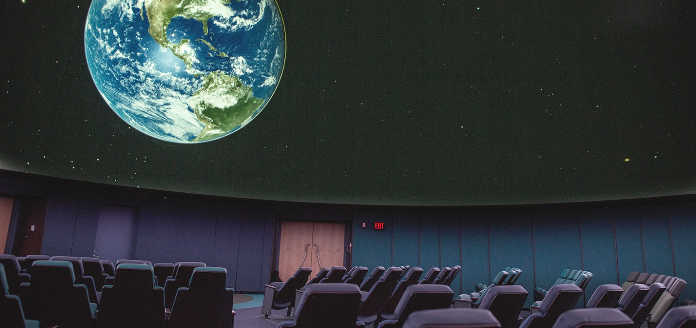
Inside the Roger B. Chaffee Planetarium.
When the show starts, a presenter will talk and the room will get dark. This will help me see the stars. After the show, the lights will come back on. If the show is too loud, I can wear headphones. I can leave the room at any time.

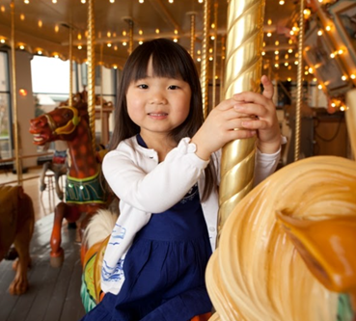
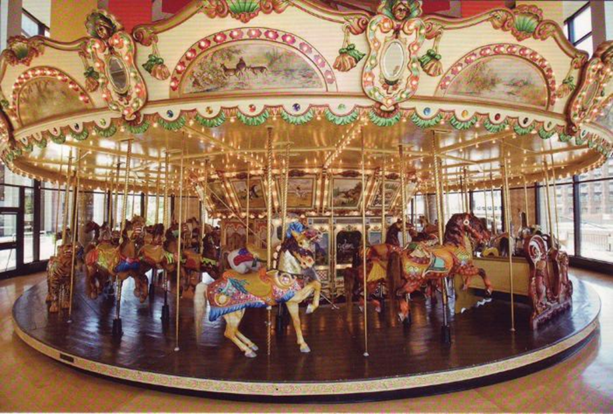
The Spillman Carousel was built in New York in 1928.
I can ride on the Spillman Carousel. It has lights and plays music. If the music is too loud, I can wear headphones. The carousel turns in a circle. Some animals move up and down. A staff member can help me choose the right seat. To stay safe, I must wait for the carousel to stop moving before I get off.
The museum café is on the second floor next to the Chafee Planetarium.
I can visit the museum café. From the windows, I can see the Grand River and downtown Grand Rapids. The café is a good place to take a break.

When I visit the Grand Rapids Public Museum, I will learn a lot about history, science, and culture. I will explore many interesting artifacts, specimens, and exhibits. The museum is big, so I may not see everything in one day. That is OK! I can save some exhibits for another day.

The Grand Rapids Public Museum’s vision is to inspire passionate curiosity and a deeper understanding of the world around us.

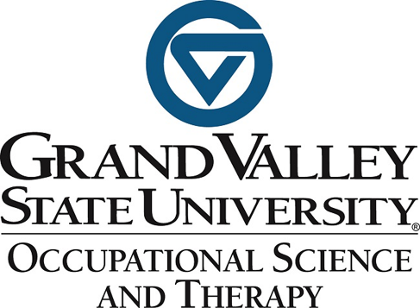
This social narrative was developed through a collaboration between the Grand Rapids Public Museum and the Occupational Science and Therapy program at Grand Valley State University.

