Visiting the
Grand Rapids Public Museum
A Social Story

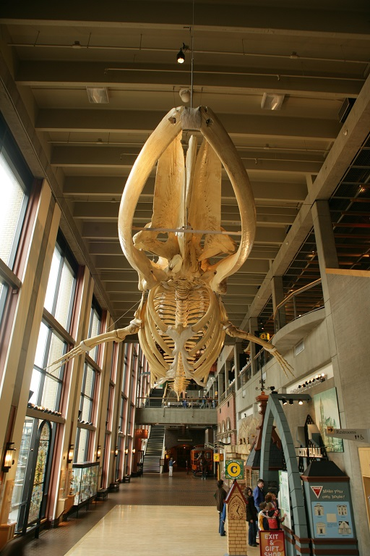


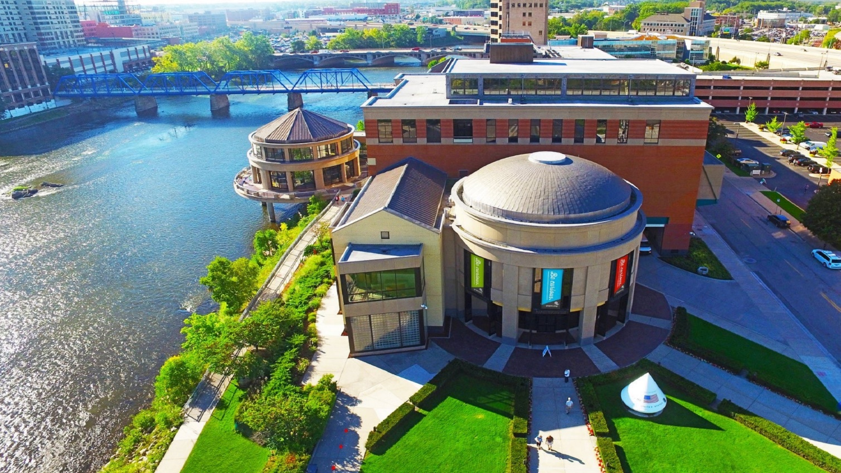
I am going to the Grand Rapids Public Museum. It is a fun place to learn about history, science, and culture. There are many things I can see and do.

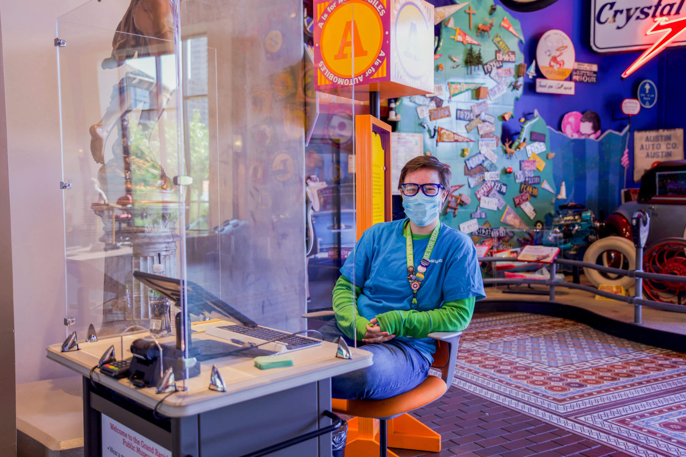
A friendly staff member sitting near the main entrance.
At the museum, I may need to wait in line. During my visit, I will stay with my grown-up and use my walking feet. If I have a question, a staff member will help me.


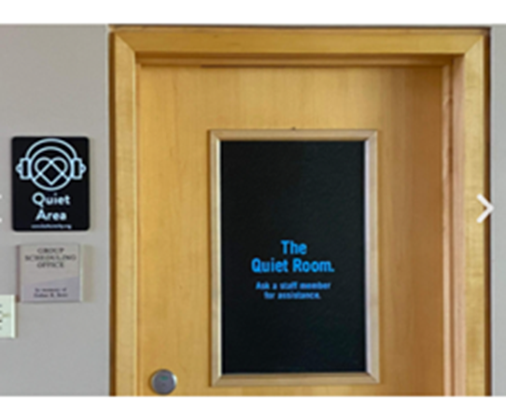
See the front desk to access the quiet room and headphones.
Sometimes the museum gets noisy. Other people are excited to be here too! If the noise gets too loud, I can take a break in the quiet room, or ask a staff member for headphones.

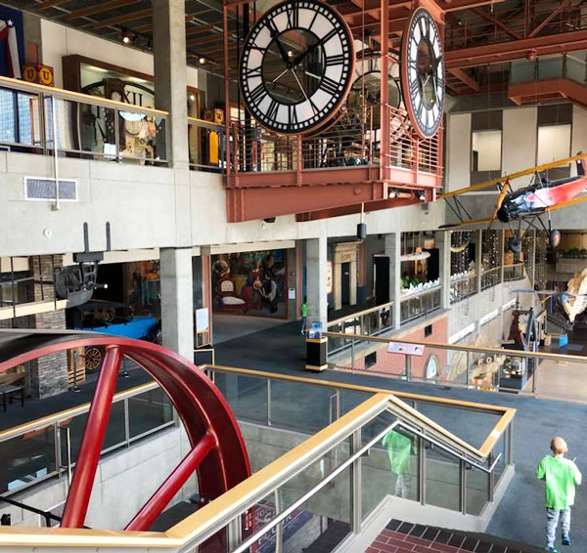
A view from the second floor at the Grand Rapids Public Museum.
The museum has three floors I can explore. When I am ready to go upstairs, I can use the elevator, or take the stairs.

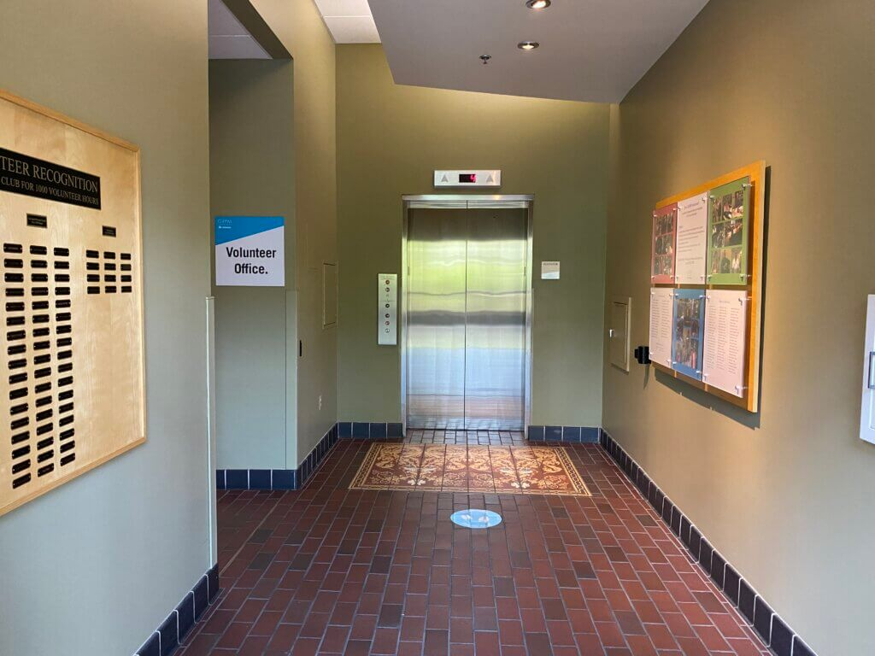
The museum has one elevator. I may have to wait in line to use the elevator. That is OK! It is good to wait so everyone can have a turn.

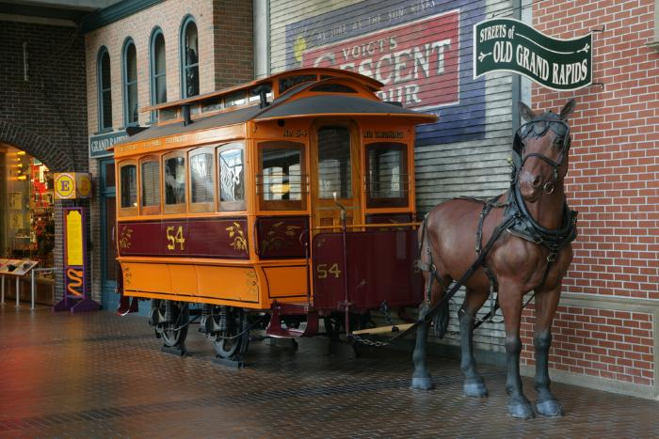
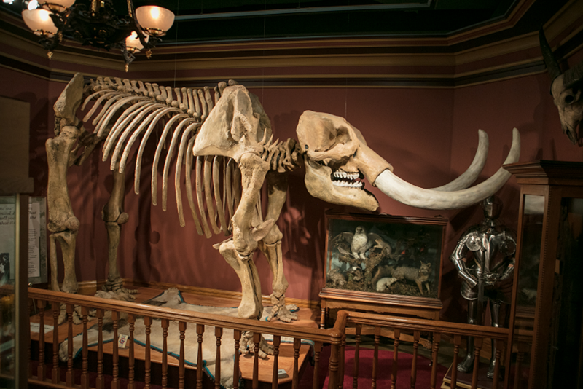
A horse drawn streetcar is a manmade artifact.
A mastodon skeleton is a scientific specimen.
When I visit the museum, I will see many manmade artifacts and scientific specimens on display. Artifacts are objects made by humans. Specimens are objects made by nature. Artifacts and specimens teach us how the world has changed over time.

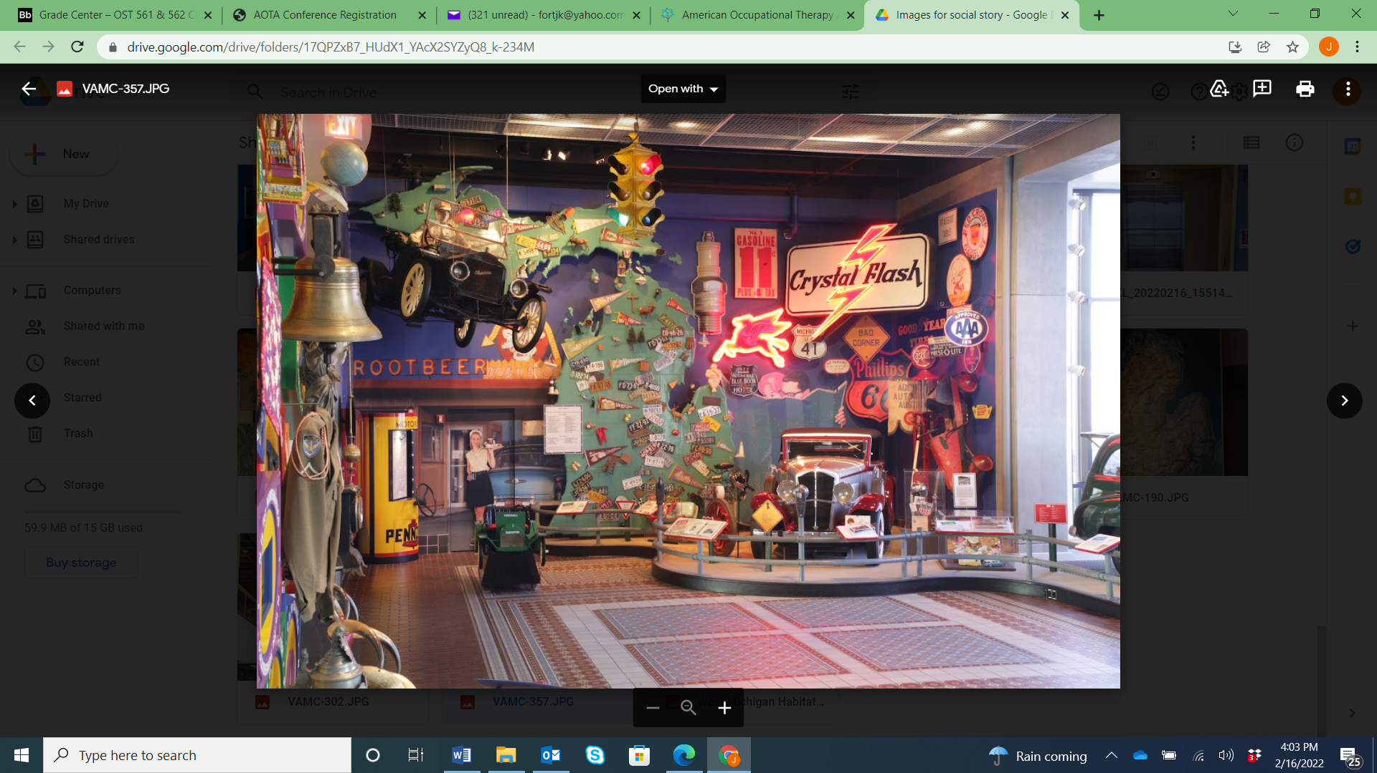
A collection of artifacts or specimen is called an exhibit. The museum has many exciting exhibits I can explore.
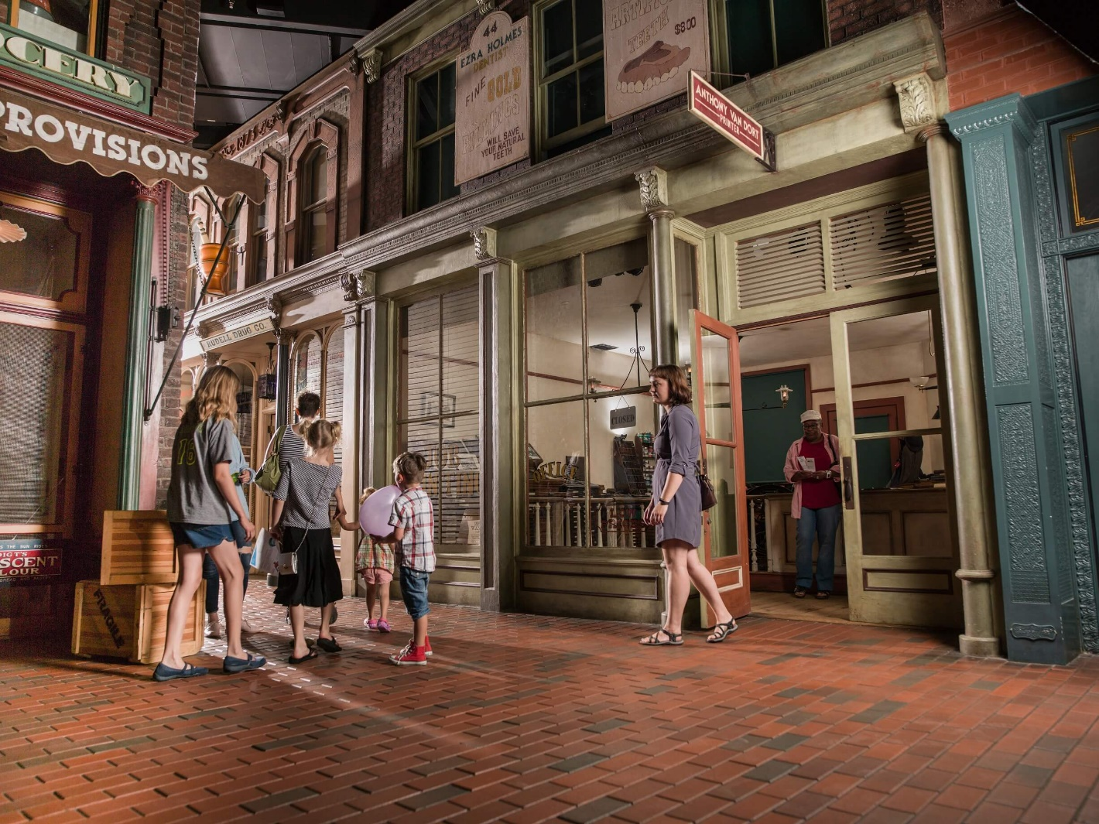

In the Streets of Old Grand Rapids exhibit, I can explore historic artifacts and storefronts. I can walk on brick streets and peddle a high wheeler bicycle. I can learn what life was like in West Michigan in the 1890’s.
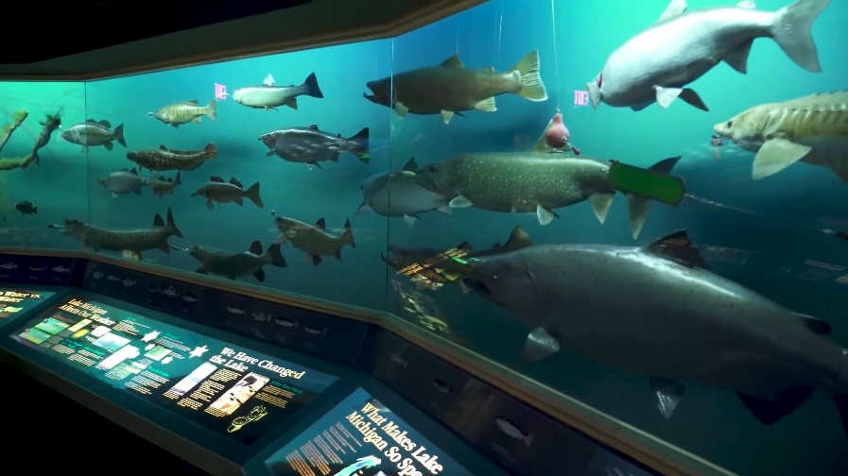
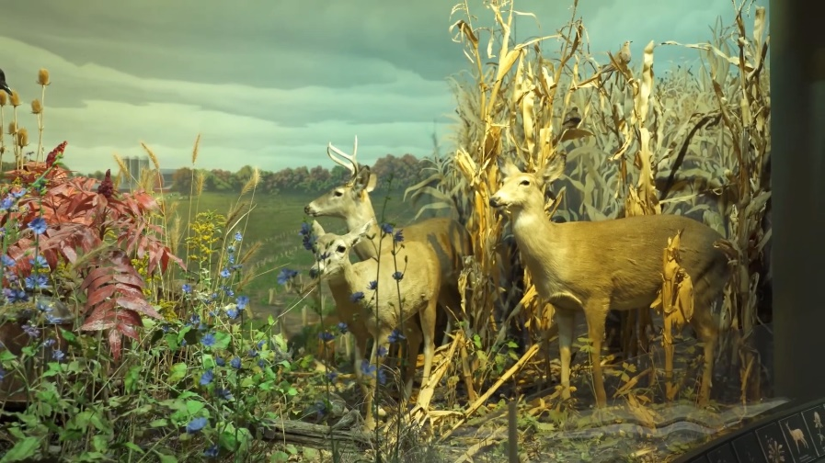
Dioramas of natural environments found in West Michigan.
In the West Michigan Habitats exhibit, I can learn about the plants, animals, and fish that live in our local lakes and forests. I can see dioramas of natural environments with interesting lights, sounds, and activities.

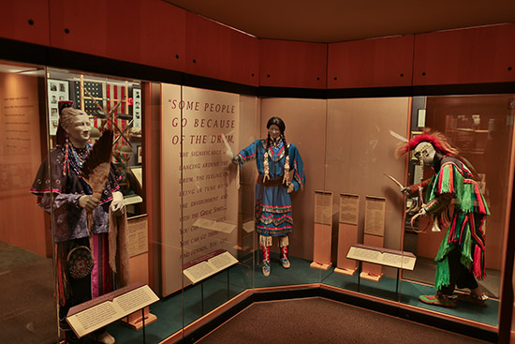
Artifacts representing the history and culture of the Anishinabek people.

In the Anishinabek: The People of this Place exhibit, I can learn about the first Native American people to settle in West Michigan. I can see many rare artifacts including decorative arts, clothing, weapons, and tools. This exhibit has a quiet area where I can get away from noise and crowds.
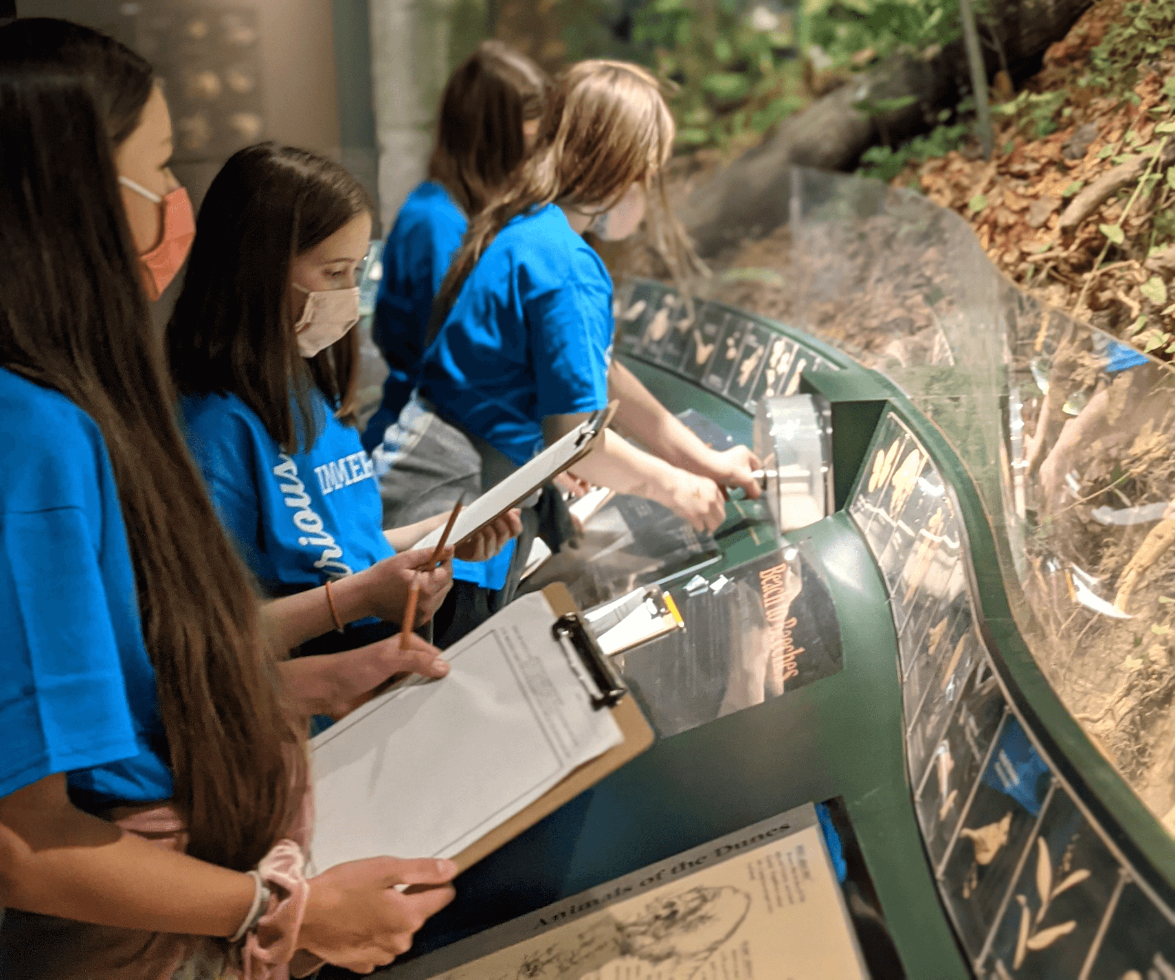
Children exploring the West Michigan Habitats exhibit.
Sometimes the museum is busy, and I may have to wait in line. That is OK! It is good to wait my turn so everyone can enjoy the exhibits.
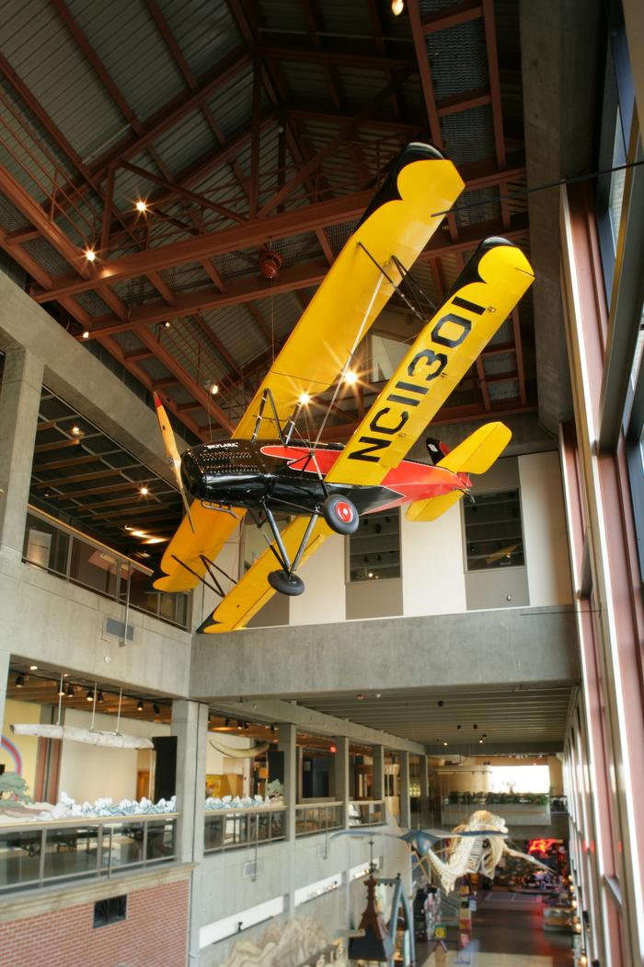
A Driggs Skylark Biplane hangs above the Galleria.
Sometimes the exhibits change. If an exhibit is closed when I visit the museum, that is OK! There are other exciting things I can see and do.
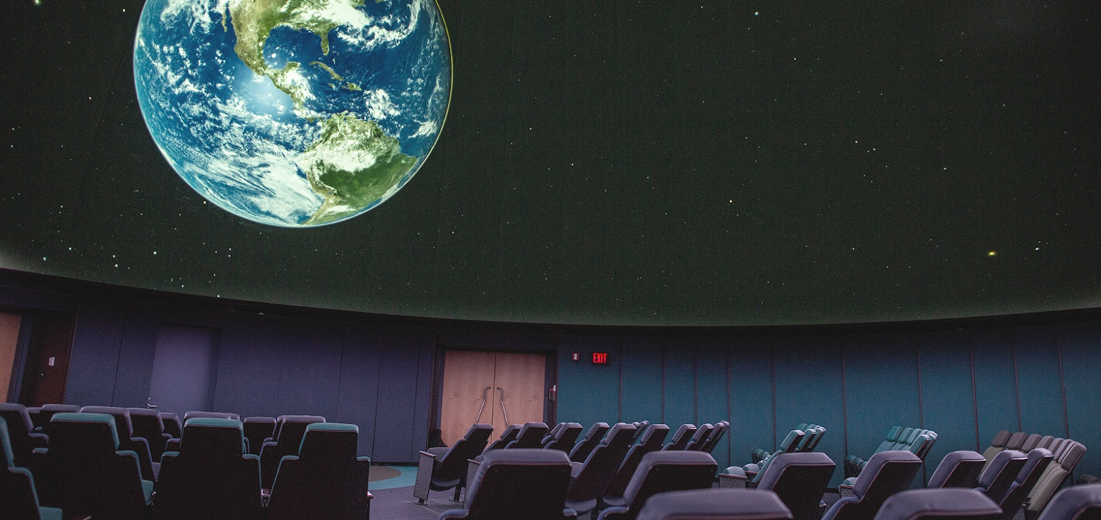
Inside the Roger B. Chaffee Planetarium.
At the Roger B. Chaffee Planetarium, I can learn about outer space. Watching a show is like going to the movies, except the movie screen is on the ceiling! If the show is too loud, I can wear headphones or leave the room at any time.

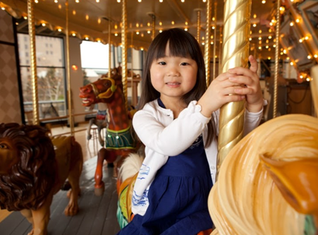
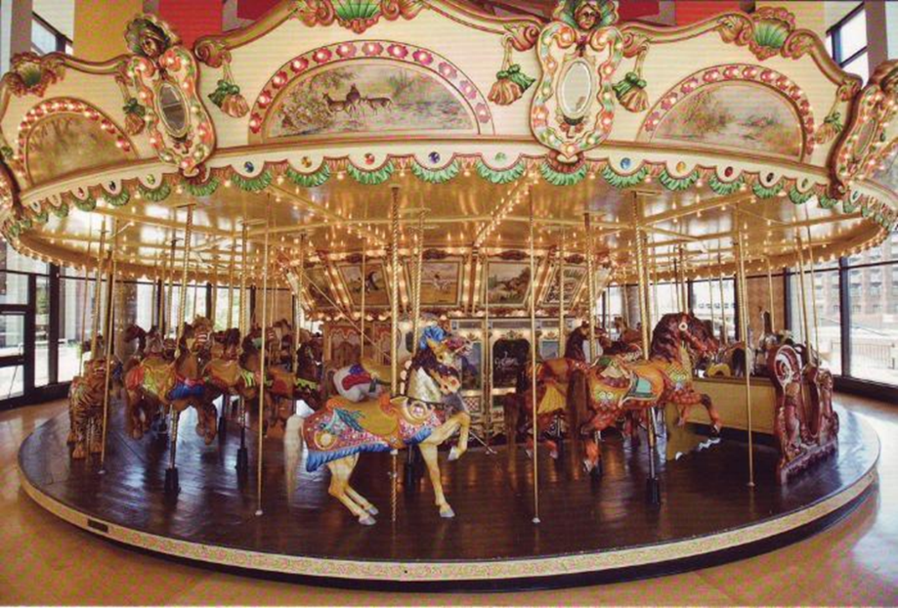
The Spillman Carousel was built in New York in 1928.
I can ride on the Spillman Carousel. It has lights and plays music. If the music is too loud, I can wear headphones. The carousel turns in a circle. Some animals move up and down. To stay safe, I must wait for the carousel to stop moving before I get off.

When I visit the Grand Rapids Public Museum, I will learn a lot about history, science, and culture. The museum is big, so I may not see everything in one day. That is OK! I can save some exhibits for another day.

The Grand Rapids Public Museum’s vision is to inspire passionate curiosity and a deeper understanding of the world around us.


This social narrative was developed through a collaboration between the Grand Rapids Public Museum and the Occupational Science and Therapy program at Grand Valley State University.

